# **eSignature Integration with Tangible**

*Product Brief*

Implementing the ability to integrate eSignature within the Tangible Platform.

**Problem Statement**

* As an IC or Client, I want the ability to send a document from the transaction manager out for eSignature within our platform.
* As a Concierge, I want the ability to send Info Sec, Emp contracts and other HR docs out to new employees for eSignature.

# **Problem with Existing Solutions**

# Many Clients do not have a CLM where they can view a transaction and immediately send associated documents out for eSignature from the same UI.

* ICs must reply on third party tools out documents for signatures if their client does not have a CLM.
* Concierge has to email documents to ICs and employees for different purposes (onboarding, etc), where they need to download, wet sign and email back, causing unnecessary emails and inefficiencies.

# **Solution**

* The ability to instantaneously execute a contract within the Tangible platform facilitates efficiency and convenience for all interested parties. eSignature also complements future features, for example being able to centrally integrate and manage their contracts into digital repositories (***future feature*** called VAULT).
* The below screenshot shows the IC and Concierge users and their possible separate workflows (please note the Client would follow a similar user flow as the IC:

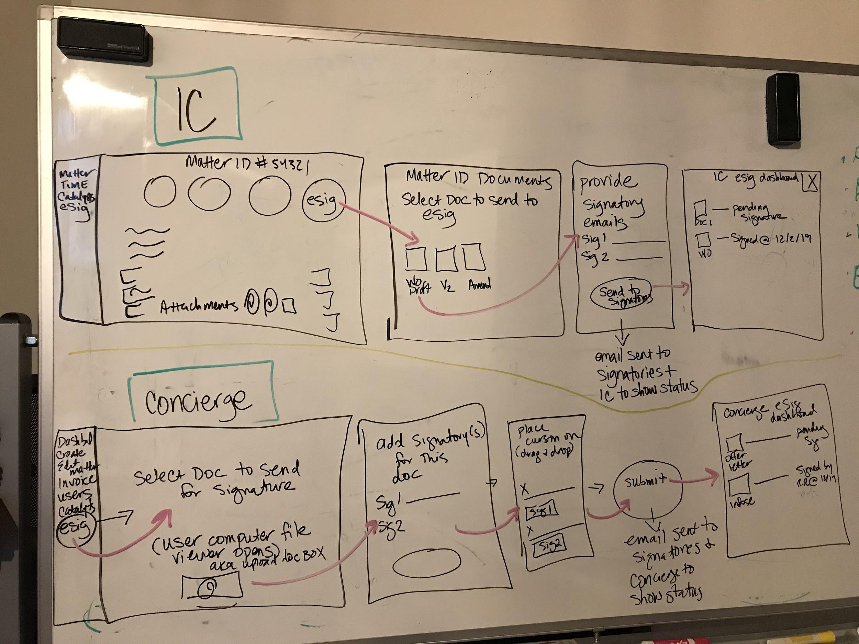

* The below screenshot shows the IC or Client view from the transaction manager:

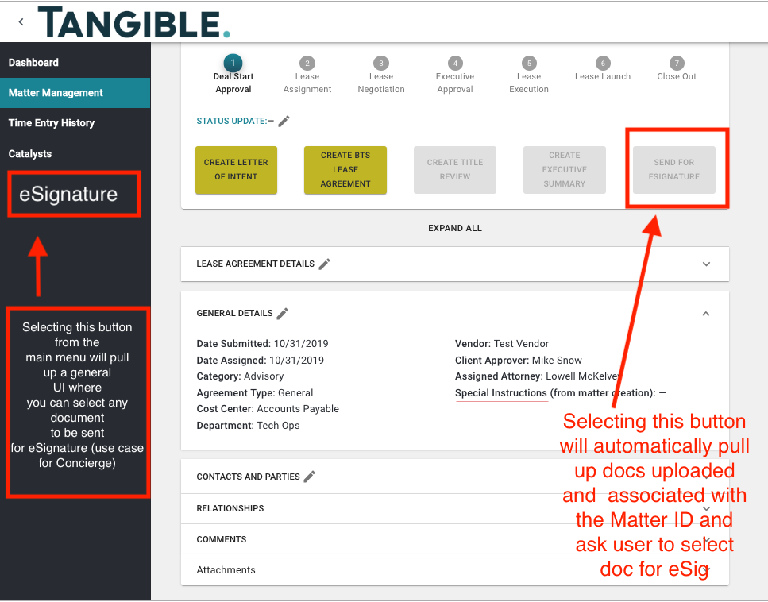

**Possible contenders**

* HelloSign -<https://app.hellosign.com/api/pricing>
  + <https://app.hellosign.com/api/documentation>
* PandaDoc -<https://www.pandadoc.com/api/>
  + <https://developers.pandadoc.com/>
* EverSign -<https://eversign.com/api#pricing>
  + <https://eversign.com/api/documentation>

# **Details/Exception**

* IC
  + If an IC is selecting the eSignature button from within the Transaction Manager for a specific Matter, they will be shown options to select previously uploaded documents relative to that Matter (docs already attached) to be sent out for signature.
* Integrating with Autto workflows (***future state -***  once a doc is generated it would be attached to the transaction manager and available to send for eSig within Tangible).
  + In the interim, ICs and Clients can upload these documents manually.

# **Not Solved/Out of Scope**

eSignature Implementation within the Tangible Platform will not solve:

* Importing signed documents from one application into Tangible
* Archiving/Searching capabilities for signed documents (***future feature*** called “Vault”)
* ICs having the capability to upload any documents from their computer and send for eSig
* Concierge having the ability to upload any documents from their computer and send for eSig
* Transaction Manager showing status of documents and signatures from within the eSig expansion panel
* Notifications within the platform when a document has been signed or taking too long for signature
  + Will receive emails for now
  + ***Future feature - Notifications within the platform***

# **Definition of Done**

When completed, the following will be deployed to production:

* IC’s and Clients will have the ability to send a document attached to the transaction manager, and associated with that Matter ID, out for eSignature through the Tangible Platform

# **Nice to Have**

* eSignature dashboard per user showing status of documents our for eSignature
* File storage for Concierge for general templates (InfoSec, Emp Contract) where they can initiate eSignature from within the platform.
* **Team**
* Justin
* Stef

# **Tracking**

|  |  |  |  |
| --- | --- | --- | --- |
| **Approved Date:** | **Approved By:** | **Start Date:** | **Completed By:** |
|  |  | 12/30/19 | 1/13/20 |

# 